**Parashat Vayikra /פרשת ויקרא**

Shabbat Adar II 8, 5768, Mar. 15, 2008

MATSATI.COM / Rightly Dividing ThWord of G-d

http://www.matsati.com | H[Umatsati@matsati.comU](mailto:matsati@matsati.com)

**Do you understand the scriptures as the first century Jews?**

**This Weeks Reading List:**   
Torah: Leviticus 1:1-6:7

Haftarah: Isaiah 43:21-44:23  
B’rit HaChadashah: Hebrews 10:1-18

In the beginning of sefer Vayikra, it says “ויקרא אל-משה...” where HaShem calls Moshe by name. What is interesting is when HaShem calls upon Moshe, He could have said “ויקרא משה” (“and He called Moshe”) but instead HaShem says “ויקרא אל-משה” which means “And He called unto Moshe.” The phrase “And He called unto Moshe” indicates that only Moshe heard his name being called and not Am Yisrael.

**1:1-2 ויקרא**



HaShem spoke to Moshe from the Ohel Moed (Tent of Meeting) indicates that the voice of Adonai was heard only by Moshe because he was inside of the Ohel Moed and the voice didn’t travel beyond the walls of the Ohel. It is here where Adonai reveals to Moshe the efficacy (effectiveness, success, power, benefit, etc) of blood offered in sacrifice for the atonement of sins. Now today we live in a new age, one which is far removed from which HaShem had given his Torah over 4000 years ago. It was another 2000 years from the giving of the Torah which Yeshua found himself born into an age of teachers including opposing views and debates of the first century. The great sages of rabbinic Judaism like Hillel, and Akiba lived within 100 years of this time.

Today we have a variety of informational systems such as television, radio, the internet, and numerous books in which our intellectual energy has been absorbed. However, the rabbis of the first century their intellectual energy was absorbed by the Bible. It wasn’t only that the scriptures were memorized, the Bible reached into every aspect of their lives. Within the first century, the Jewish life was examined against a background of quotations (scriptures) embedded in ones soul (primary means for knowing the scriptures was through memorization). Everything in life was referred back to the text of scripture from daily work, to family, interaction within the community, between neighbors, and any spiritual experiences that might occur. The Rabbinic literature of the time indicates the rabbis were educated Jews who lived the scriptural text. The bible was the measuring stick which all of life was measured. This is where the people were in the first century. As a good teacher, Yeshua also began where the people were because the Jewish community was rooted within the holy texts. For example, Yeshua says on the sermon of the mount (see *Matthew 5*) he begins with “you have heard … but I say?” Yeshua begins this way because he is dealing with a community of people who the word of G-d is alive and ever present. Therefore, if we wish to really understand what Yeshua is talking about we have to try to enter the minds of the listeners. This is why the Jewish people and Judaism have so much to offer for our understanding of Yeshua. There is however an obstacle to deal with when attempting to understand Yeshua with respect to rabbinic Judaism. This obstical relates to a religious divide; Judaism believes the character of Yeshua has betrayed Judaism and Christians are reluctant to listen to Judaism speak about Yeshua because Christian thinking is one in which Yeshua should only be understood in light of Christian teaching and dogma.

With this in mind, let’s get back to the parsha, we find it is here where Adonai reveals to Moshe the efficacy of blood atonement for sins. In Judaism the daily synagogue services are thought of as having replaced the daily Temple sacrifice. We can easily see this in the Siddur during the first part of the Shacharit (morning) service in the Korbanot section includes portions recalling the sacrifices and offering the bulls of our lips.



Other portions of the liturgy are directly concerned with sin and forgiveness, for example, the 5th and 6th blessings of the Amidah and the Tachanunim (supplications). As you know the temple no longer exists, it is the daily synagogue service which serves as a reminder of sins year after year. In fact, it makes sense for the Conservative and Reformed Jewish movements to apply the term “Temple” to synagogues if synagogue prayers are equivalent to Temple sacrifices. However, according to this week’s Parsha, Parashat Vayikra, everything is purified by blood.

Numerous examples in the Torah testify to the significance of and the need for blood atonement. (see *Exodus 29-30, Leviticus 1-9, 14-17*) Without the shedding of blood there is no forgiveness of sins. This basic principle is minimized in Judaism today. Some reasoning behind this mindset that blood is no longer required comes from various sources.

**Sources of altered interpretation**

1. To begin, it is a good idea to look at the source of G’millut HaSadim (deeds of loving kindness). In my own personal library, I have The Schottenstein Hebrew Edition of the Talmud Bavli, from the Mesorah Heritage Foundation; you can find it here <http://www.artscroll.com/Talmud1.htm#hebrew>. The key figure in history is Yochanan Ben-Zakhai, who led the Synod of Yavneh (90 C.E.) in reorienting Judaism toward halakhah (“law”) and away from the sacrificial system after the destruction of the Temple. I have scanned in the relevant pages from the Talmud Bavli and placed them in the document below, I also highlighted the Hebrew text whose translation is given below. Reading B’rakhot 28b, Yochanan Ben-Zakhai had a significant influence upon Judaism in his instruction on G’milut HaSadim, however, Yochanan apparently continued to have sins on his conscience even on his death bed. Yochanan realizes that forgiveness is ultimately by the grace of HaShem and contemplates what is ahead of him, Heaven or Hell. (Note: anyone who claims Judaism does not have a concept of Hell is clearly mistaken, here we find mention of Hell from back to 90 C.E.) Below is the translation of Yochanan Ben-Zakhai, you can see the helplessness he feels outside of the atonement which is prescribed in the Torah.

***B’rakhot 28b***

*“Now I am being led before the supreme King of Kings, the Holy One, blessed be He, who lives and endures forever and ever. If he is angry with me, he is angry forever. If he imprisons me, he imprisons me forever. If he puts me to death, he puts me to death forever. I can’t persuade him with words or bribe him with money. Moreover, there are two ways ahead of me: one leads to Gan-Eden (Heaven) and the other to Gey-Hinnom (Hell), and I do not know which one will take me. How can I do anything but weep?”*

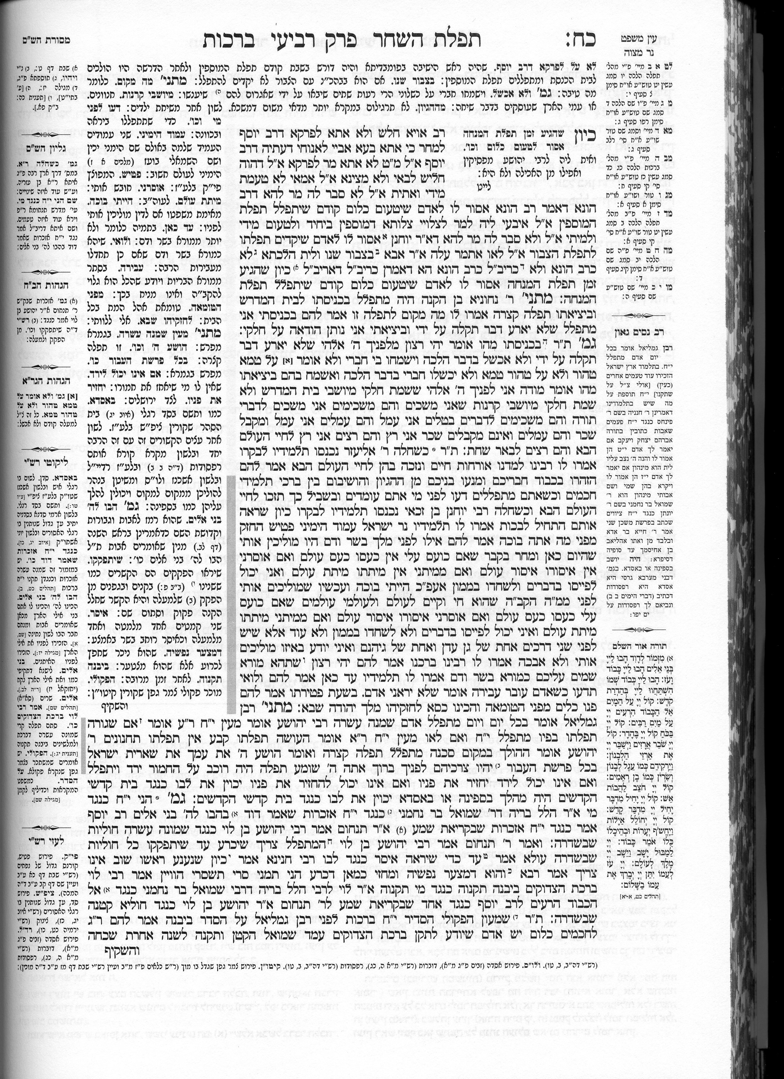

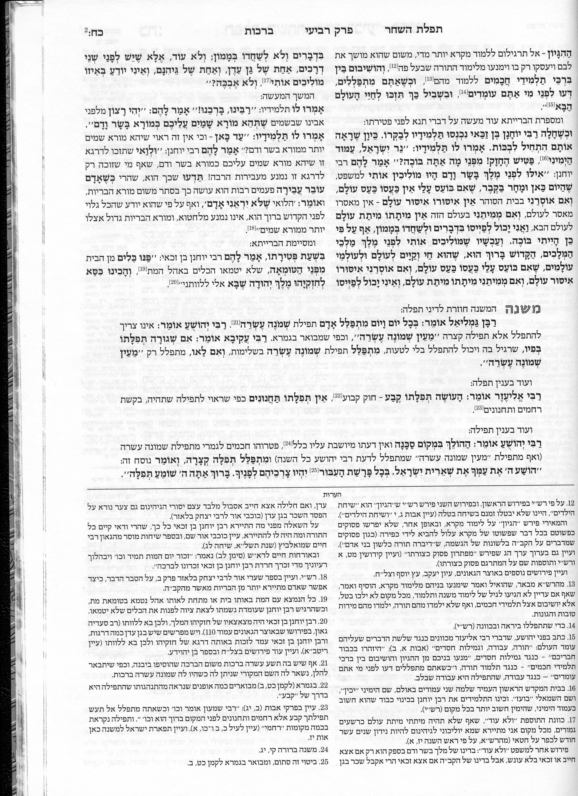

1. Borrowing from secular philosophy with the idea that modern man has evolved past the kind of primitive religion that portrays G-d as requiring blood atonement. For example Reformed Judaism has removed from the “Amidah” of its prayer books all references to the restoration of sacrifices. However, on the other hand, Orthodox Judaism (i.e. the Temple institute) prays three times a day for the rebuilding of the Temple so the daily sacrifices will be restored and offered in the manner which is prescribed by the Torah.
2. Various scripture verses which appear to minimize the importance of animal sacrifices. For example, Isaiah 1:11-17 says “I am full of the burn offerings of rams and the fat of fed beasts; I do not delight in the blood of bulls, lambs or goats …who has required this of you? … Do not bring vain oblations any longer; it is an offering of abomination to me.” Even Yeshua mentions Hosea 6:6 “I want compassion rather than animal-sacrifice.” These verses and various others found in the Tanach are used as proof text for receiving forgiveness of sins outside of blood atonement.

Thus far we have established that within Judaism, it is believed blood atonement is unnecessary and have given the mindset behind such conclusions. Next, let’s look at what the Torah says: “blood makes atonement by the reason of the life.”

***Leviticus 17:11***

*17:11 For the life of a creature is in the blood, and I have given it to you on the altar to make atonement for yourselves; for it is the blood that makes atonement because of the life.' (כִּי נֶפֶשׁ הַבָּשָׂר בַּדָּם הִוא וַאֲנִי נְתַתִּיו לָכֶם עַל־הַמִּזְבֵּחַ לְכַפֵּר עַל־נַפְשֹׁתֵיכֶם כִּֽי־הַדָּם הוּא בַּנֶּפֶשׁ יְכַפֵּֽר׃) (CJB)*

In light of modern philosophy and various scriptures which appear to minimize the sacrificial system, how can we understand these arguments from the perspective of the first century? The answer to these reasons is that animal sacrifices offered by people who lack compassion, whose “hands are full of blood,” and who do not “seek justice, relieve the oppressed, judge the fatherless fairly or plead on behalf of the widow” (see *Isaiah 1:15-17* and *James 1:27*) are useless and an abomination before Adonai.

***Mica 6:6-7***

*6:6 "With what can I come before ADONAI to bow down before God on high? Should I come before him with burnt offerings? with calves in their first year? 6:7 Would ADONAI take delight in thousands of rams with ten thousand rivers of olive oil? Could I give my firstborn to pay for my crimes, the fruit of my body for the sin of my soul?" 6:8 Human being, you have already been told what is good, what ADONAI demands of you - no more than to act justly, love grace and walk in purity with your God. (CJB)*

Other similar passages such as 1 Samuel 15:22, Amos 5:2, Psalms 40:7-9, it is made clear the authors do not regard such verse as downgrading the sacrificial system. Rather, that HaShem regards the sacrificial system only in light of those whose hearts are right. Only those whose hearts are right can offer blood sacrifices that will please HaShem; “repentance, prayer, and tzedakah (righteousness)” are necessary prerequisite (something that is required for) for acceptable sacrifice, but not substitutes for it. This is true not only from the beginning of the history of Yisrael (through the Tanach) but also with the last prophet Malachi who writes that in the Messianic times, when Adonai suddenly comes to His Temple along with the “messenger of the covenant” which is understood to be the Messiah Yeshua.

***Malachi 3:1-4***

*3:1 "Look! I am sending my messenger to clear the way before me; and the Lord, whom you seek, will suddenly come to his temple. Yes, the messenger of the covenant, in whom you take such delight - look! Here he comes," says ADONAI-Tzva'ot. 3:2 But who can endure the day when he comes? Who can stand when he appears? For he will be like a refiner's fire, like the soapmaker's lye. 3:3 He will sit, testing and purifying the silver; he will purify the sons of Levi, refining them like gold and silver, so that they can bring offerings to ADONAI uprightly. 3:4 Then the offering of Y'hudah and Yerushalayim will be pleasing to ADONAI, as it was in the days of old, as in years gone by. (CJB)*

Repentance, prayer, and righteousness have its application in offering G-d “a sacrifice of praise continually” thanking Him that Yeshua has provided a once and for all kapporah, a blood atonement for sin because as the verse says “without the shedding of blood there is no forgiveness of sins.” This kind of sacrificial offering will be pleasant to Adonai, as in ancient times. *Hebrews 13:15 Through him, therefore, let us offer God a sacrifice of praise continually. For this is the natural product of lips that acknowledge his name. (וְעַתָּה נַקְרִיב עַל־יָדוֹ זִבְחֵי תוֹדָה לֵאלהִים תָּמִיד הֲלא הֵם פְּרִי שְׂפָתֵינוּ הַנֹּתְנוֹת תּוֹדָה לִשְׁמוֹ׃) (CJB)*

**Be Blessed in Yeshua our Messiah!**

* * * * * * * * * * * * * * * * * * * * * * * * * * * * * * * * * * * * * * * * * * * * * * * *

**הללויה לאדוננו מורנו ורבינו ישוע מלך המשיח לעולם ועד:**

Hallelujah for our Lord, our Teacher, our Rabbi,

“Yeshua” King Messiah forever and ever