**פרשת מסעי / Parashat Masei**

**Bamidbar / Numbers 33:50-54**

33:50 Then the Lord spoke to Moses in the plains of Moab by the Jordan opposite Jericho, saying, 33:51 ‘Speak to the sons of Israel and say to them, 'When you cross over the Jordan into the land of Canaan, 33:52 then you shall drive out all the inhabitants of the land from before you, and destroy all their figured stones, and destroy all their molten images and demolish all their high places; 33:53 and you shall take possession of the land and live in it, for I have given the land to you to possess it. 33:54 'You shall inherit the land by lot according to your families; to the larger you shall give more inheritance, and to the smaller you shall give less inheritance. Wherever the lot falls to anyone, that shall be his. You shall inherit according to the tribes of your fathers. (NASB)

Shabbat Av 1, 5768, August 2, 2008

MATSATI.COM / Rightly Dividing The Word of G-d

http://www.matsati.com | H[Umatsati@matsati.comU](mailto:matsati@matsati.com)

**Have you destroyed the strongholds in your life?**

|  |  |
| --- | --- |
| **השבועות הזה קוראים / This Week’s Reading** | |
| **תורה:**  **הפטרה:**  **הברית:**  **החדשה:** | Numbers 33:1-36:13  Jeremiah 2:4-28 James 4:1-12 |

**Bamidbar / Numbers 33:1-33:49**



HaShem said to Moshe in the plains of Moab a warning and a command in *Bamidbar / Numbers 33:52* which caught my attention. Have you ever considered this topic in which HaShem warns Yisrael what will happen once they cross over into the Promised Land? Verse *33:52* we can divide into three parts:

1. Drive out all who dwell in the land from before your face
2. Destroy all the idols
3. Destroy all the high places

Today I believe this has great application for our lives. When we read about idolatry in the Tanach and the Ketuvei Shelachim (Apostolic Writings), what usually comes to your mind? Generally speaking, the concept of idolatry has been thought of mostly involving worshiping some inanimate object. For example Ashtoreth worship:

Ashtoreth is the moon goddess of the Phoenicians, representing the passive principle in nature, their principal female deity and is frequently association with the name of Baal, the sun-god, their chief deity. See *Judges 10:6* and *1 Samuel 7:4; 12:10* for more information. These names also occur in the plural (Ashtoroth, and Baalim) probably as indicating either different statues or different modifications of the deities. This deity is spoken of as Ashtoreth of the Zidonians. She was the Ishtar of the Accadians and the Astarte of the Greeks (see *Jeremiah 44:17; 1 Kings 11:5, 33:2; 2 Kings 23:13*). There was a temple of this goddess among the philistines in the time of Saul (see *1 Samuel 31:10*). Under the name of Ishtar, she was one of the great deities of the Assyrians. (Note this is the name of whose morphological equal is “Easter”) The Phoenicians’ called her Astarte. Solomon introduced the worship of this idol in *1 Kings 11:33*. Jezebel’s 400 priests were also probably employed in its service in *1 Kings 18:19*. Ashtoreth was also called the “queen of heaven” in *Jeremiah 44:25*.

I thought it would advantageous to look at the Leningrad codex on this verse, *Bamidbar / Numbers 33:52* and by doing so I was very surprised by what I found.

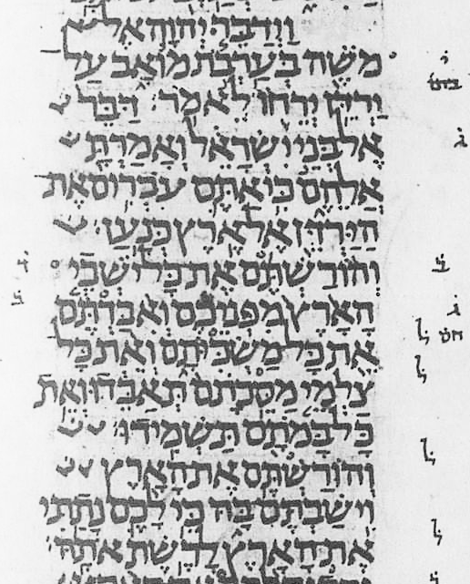

The abbreviated notes of the Masorah parva are in the margins of the Leningrad codex. The note itself is placed adjacent to the line to which it refers and a small circle (circule) is placed above the word. The note here is a lamed with a dot over it which stands for לא אית meaning “Unique, occurs only once” indicating the word or phrase occurs only here in exactly this form.

The question before us now … what is the significance of the unique spelling for the Hebrew word “molten image” that is not found spelled in the same way anywhere else in the Tanach? Is it to draw our attention to the word? It certainly drew the attention of the Soferim (scribes). The Masorah is a collection of critical and grammatical notes on the text of the Tanach whose purpose of which was to guard the text from degeneration and corruption and to ensure its accurate transmission for all time. Through the preservation of the Hebrew text we find this uniqueness of the written words … but can we draw a deeper meaning from the text as a result? I would like to think so … this concept of purging the Promised Land of the idols and high places of worship can certainly be applied to our hearts like the prophet Ezekiel did:

***Ezekiel 14:3-5***

*14:3 ‘Son of man, these men have set up their idols in their hearts and have put right before their faces the stumbling block of their iniquity. Should I be consulted by them at all? 14:4 ‘Therefore speak to them and tell them, 'Thus says the Lord God, ‘Any man of the house of Israel who sets up his idols in his heart, puts right before his face the stumbling block of his iniquity, and then comes to the prophet, I the Lord will be brought to give him an answer in the matter in view of the multitude of his idols, 14:5 in order to lay hold of the hearts of the house of Israel who are estranged from Me through all their idols.’' (NASB)*

The idols which Ezekiel speaks of concerns those we establish in our hearts. Such idols of the heart include personal pride, finances, education (what we know or ridiculing others who don’t know so much), etc. I would also suggest that trying to please everyone else over and above trying to please Adonai can be a form of idolatry. The one thing we lack today is discernment, and especially discernment of what HaSatan throws at us to keep us in bondage.

As always there are valuable lessons we can learn in studying the scriptures. Here in these verses we find Hashem is calling attention to the idols and high places Yisrael needed to tear down in the Promised Land. In the same way we need to tear down the idols we have in our hearts. Take for example today, ask yourself the following question: am I more concerned with which sports team is winning and/or will be in the Super Bowl or the World Series, what is the latest hottest piece of clothing a particular actor/movie star is wearing? Is there anything in my life that might draw my attention away from focusing upon the Lord and His messiah Yeshua?

Let’s have a look at this idea of idolatry from a different perspective. Let’s consider the gods of the nations that were worshiped in the Tanach. For example Baal (בעל, Canaanite god) and Molech (מלך, fire god of the Ammonites); have you ever considered the meaning of the Hebrew names of these false gods? Baal / בעל means husband or spouse and Molech /מלך means king. Isn’t it interesting the names of these deities are named husband and king? In the scriptures we find that our relationship with G-d is sometimes analogized like that of a marriage, where we are the bride and HaShem is the husband. Throughout the scriptures we are told HaShem is supposed to be king of our lives. Is it possible the worship of these false gods brought with it meaning beyond just the physical act of worshiping an inanimate molten image and that there was a deeper spiritual intimacy that was involved that reaches deep into the soul of its practitioner?

**Conclusion**

One of the problems today is many believers are drifting into a very modern and liberal approach to scripture. We need to break free of this by understanding the sovereign work of G-d, in that by His Spirit, in the act of inspiring the Holy Scriptures He has revealed to us the spiritual intimacy of our physical acts and its relationship to our thought life. This concept of purging the Promised Land of the idols and high places of worship draws with it the concept of removing all the stumbling blocks that might possibly cause the children of Yisrael to fall into sin and forget about the Lord. In the same way Hashem wants us to clean up the areas of our life that might cause us to fall into repetitive sin.

This week’s parsha actually details the physical boarders for the land of Yisrael in which Joshua (Yehoshua) was to cause beni Yisrael (the children of Yisrael) to inherit. It is interesting to note how the Tanach and the Ketuvei Shelachim (Apostolic writings) continually make reference to this Promised Land causing the land of Yisrael to become a central concern. The land matters to HaShem because it is the place where G-d placed his presence. Today, in the Messiah Yeshua, HaShem made another promise, that is to cause His Spirit to dwell within you and me. This in no way minimizes the land of Yisrael and its spiritual importance because the prophets have always said when the Messiah comes He will gather all the people of Yisrael back to the land of Yisrael. The indwelling spirit does however imply HaShem is causing his presence to dwell within us and all the more reason why we need to clean up our lives in the same way Beni Yisrael needed to clean of the land

***1 Corinthians 6:19-20***

*6:19 Or do you not know that your body is a temple of the Holy Spirit who is in you, whom you have from God, and that you are not your own? 6:20 For you have been bought with a price: therefore glorify God in your body. (NASB)*

As we continue on in our faith in Yeshua the Messiah, we must continue to take steps which encourage our own spiritual growth. We know the Tanach is the foundation of it all, in the inspired scriptures of the Torah, Prophets, and Writings we discover who HaShem is, who we are, and how we relate to G-d through faith in His Messiah and how we are to live in order to honor him and become His covenant partners. It is also the book in which describes who we are in Him and the Ketuvei Shelachim (Apostolic writings) are the inspired continuation of the Tanach showing us how perfectly HaShem keeps his promises in Yeshua the messiah.

**Be Blessed in Yeshua our Messiah!**

* * * * * * * * * * * * * * * * * * * * * * * * * * * * * * * * * * * * * * *

**הללויה לאדוננו מורנו ורבינו ישוע מלך המשיח לעולם ועד:**

Hallelujah for our Lord, our Teacher, our Rabbi,

“Yeshua” King Messiah forever and ever