**פרשת עקב / Parashat Eikev**

Shabbat Av 22, 5768, August 23, 2008

MATSATI.COM / Rightly Dividing The Word of G-d

http://www.matsati.com | H[Umatsati@matsati.comU](mailto:matsati@matsati.com)

**Is your life ordinary or extraordinary?**

|  |  |
| --- | --- |
| **השבועות הזה קוראים / This Week’s Reading** | |
| **תורה:**  **הפטרה:**  **הברית:**  **החדשה:** | Deuteronomy 7:12-11:25  Isaiah 49:14-51:3 Hebrews 11:8-13 Romans 8:31-39 |

The Jewish men who wrote the scriptures participated in the thought forms of their time, this includes certain principles of interpretation (Hermeneutical rules and Hebrew middot, “measures, norms”) widely used in the Hebrew bible. We find various examples of middot today in Judaism in various halakhic commentary (i.e. Rabbi Ishmael on the thirteen middot in the introduction to Sifra on the book of Leviticus compiled in the fourth century). Recently I have been having a discussion that has been reoccurring more and more frequently, the topic “obedience.” To understand the role of obedience in our lives as believers it is a requirement that we have an understanding of the certain principles of interpretation we find in the Hebrew Bible (the Hebraic Mind). In this week’s parsha I would like to look at historically we attempt to do things the easy way over against what is difficult and then look at what the Torah and Yeshua requires of us.

**What is easy and what is difficult?**

Last week’s parsha (Parashat Vaetchanan) and this week’s parsha (Parashat Eikev) contain one of the most important portions of the Torah in Judaism known by the title “the Shma.” The obligation to study the Torah is found here in *Devarim / Deuteronomy 6:6* where we are told to place these words upon our hearts and, according to the rabbinic sages, requires us to read daily the entire mitzvah (commandment) section:

The Shma

**6:4-6דברים**

Command to place all of these words upon our hearts.



**חז''ל / Chazal**

This is an acronym for “חכמינו זכרונם לברכה” (**Ch**achameinu **Z**ichronam **L**ivracha) which literally means “our sages of blessed memory.” This generally refers to the Talmudic sages as a whole or as an individual.

Is there any doubt over why the Chazal’s decided that we read these parshiot to fulfill our daily obligation to study Torah? (this section begins with the “shma” *Devarim / Deuteronomy 6:4-8* and ends with “v’haya im shmoah” *Devarim / Deuteronomy 11:13-21* Note: if we really look at sefer Devarim we would see the list of mitzvah would not end until around chapter 21). One of the essential parts of the morning and evening prayers, the “kriyat shma” includes these scriptures. These scriptures are recited twice a day in the rabbinical prescribed daily prayers, they are written on the mezuzah, and are also the verses which are contained in the boxes of tefillin. Looking at these scriptures the entire section is quite lengthy. As a result it was decided by the Chazal that one only needs to read the opening and closing parshiot to fulfill the mitzvah found in 6:6. We find this in the Talmud Bavli, Mishnah Sota 41a (תלמוד בבלי מסכת סוטה דף מא עתוד א) shown below.

**תפלין / Tefillin**

Also called the phylacteries are two boxes which contain biblical verses and use leather straps to attach them to ones body. Tefillin are essential elements in traditional Jewish prayer during the morning prayer services in Orthodox and Conservative Judaism.

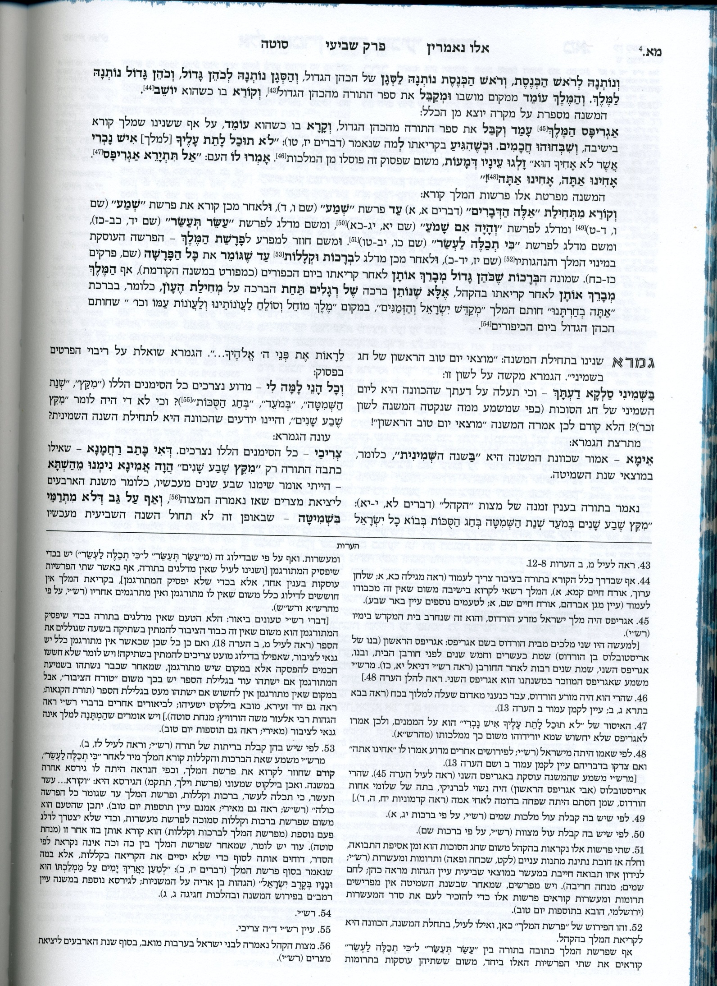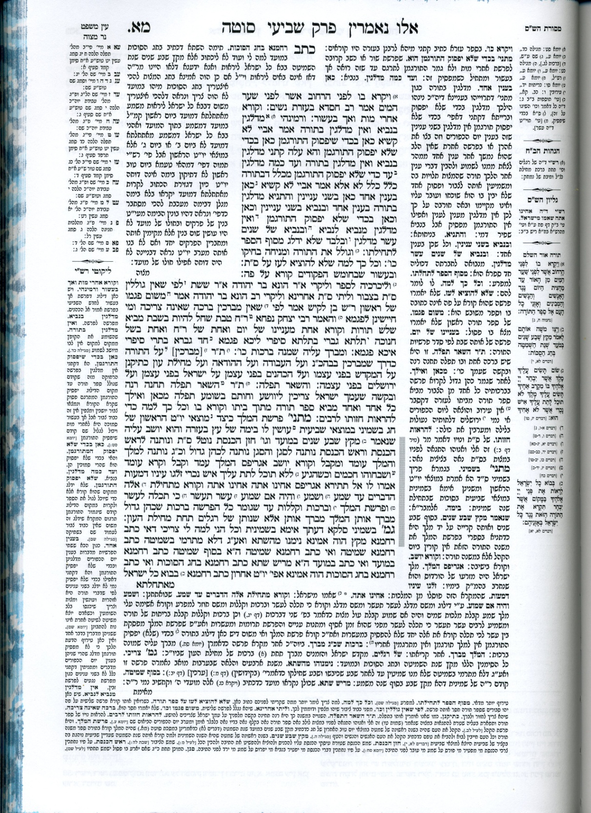

In the Mishnah, Mesechet Sota 41a, shown above, the Chazal concluded by reading these two parshiot it is as if one had read all of the mitzvot of this mitzvah section. During the Hakhel (gathering) ceremony, instead of reading the entire speech the custom was to read the first parsha “shma” (*6:6-8*) and then skip to the last parsha “v’haya im shmoah” (*11:13-21*).

Clearly, in the Torah, it is required of us to read, study, and commit the Torah to memory. The problem with the rabbinic ruling in sota 41a is shortening the required mitzvot to the opening and closing pasukim (passages). Because of the length of scripture reading we find even in history this typical characteristic of mankind to make something easier or more convenient. The problem in this case occurs when tradition can affect our spiritual growth. Let’s illustrate this further by looking at the Ketuvei Shelachim (Apostolic Writings):

***Mark 7:1-5***

*7:1 The Pharisees and some of the scribes gathered around Him when they had come from Jerusalem, 7:2 and had seen that some of His disciples were eating their bread with impure hands, that is, unwashed. 7:3 (For the Pharisees and all the Jews do not eat unless they carefully wash their hands, thus observing the traditions of the elders; 7:4 and when they come from the market place, they do not eat unless they cleanse themselves; and there are many other things which they have received in order to observe, such as the washing of cups and pitchers and copper pots.) 7:5 The Pharisees and the scribes asked Him, ‘Why do Your disciples not walk according to the tradition of the elders, but eat their bread with impure hands?’ (NASB)*

In this portion of scripture, the Pharisees had interpreted the written Torah and their sages and their rabbis had decreed additional rules which related to the washing of hands. These rulings had come together to be known as “the Traditions of the elders” and later on it was to be known as the Oral Torah (See *Matthew 5:17, 12:2-11, 18:18-20, and 23:2*). Eventually it was put into written form in the Mishnah (משנה), in the second and third centuries, and expanded upon in the Gemara in the fourth and fifth centuries. This recorded account of the ritual hand washing actually corresponds to the details which are listed in the Mishnah tractate Yadayim. It was thought in the market place one may come into contact with a ceremonially unclean/impure thing. This impurity can subsequently be removed by rinsing the hands up to the wrist. This tradition is observed even until this day by orthodox Jewish men before meals. Rabbinically speaking, this isn’t done for personal hygiene rather it is believed a man’s home is his temple and the dining table being his altar, the food his sacrifice and himself the cohen (priest). Since the Tanach requires the cohanim (priests) to be ritually pure before offering sacrifices on the Temple altar, the Mishnah requires the same before eating a meal.

I feel this verse very clearly illustrates a point many Christians believe Yeshua responded to this question found in verse *7:5* condemning all Pharisaic tradition. The fact is Yeshua only objected to those practices of the Pharisees that placed human tradition above HaShem’s command. Traditions are an important part of life. For example, a state cannot be run by a constitution alone without legislation. Likewise Yisrael could not be run by the Written Torah alone without its practical application which is implied in the concept of tradition. Just as a countries legislation cannot contradict or supplant its constitution so too the traditions whether Jewish, Christian or Messianic cannot violate or alter HaShem’s word.

In our requirement to study the Torah we need to be careful to not over simplify things as is illustrated in the Talmud Bavli, Mishnah Sota 41a. In the process of simplification it is possible to make the study of Torah a trivial thing and when that occurs our desire to draw near to HaShem in the study of His word becomes more of a tradition than a relationship.

**Devarim / Deuteronomy 7:12-15**

7:12 ‘Then it shall come about, because you listen to these judgments and keep and do them, that the Lord your God will keep with you His covenant and His lovingkindness which He swore to your forefathers. 7:13 ‘He will love you and bless you and multiply you; He will also bless the fruit of your womb and the fruit of your ground, your grain and your new wine and your oil, the increase of your herd and the young of your flock, in the land which He swore to your forefathers to give you. 7:14 ‘You shall be blessed above all peoples; there will be no male or female barren among you or among your cattle. 7:15 ‘The Lord will remove from you all sickness; and He will not put on you any of the harmful diseases of Egypt which you have known, but He will lay them on all who hate you. (NASB)

HaShem asks us to do one thing, which is to believe in Him. In the Torah it is stated over and over again to believe in the word of G-d and keep His mitzvot (commandments). If we can’t believe in His word how is it possible for us to believe in him? Let’s look at a portion of scripture from this week’s parsha *Devarim / Deuteronomy 7:12-15*



Here Moshe is telling the children of Yisrael to listen to these judgments, to keep them, and to do them. In light of these scriptures are we submitting to Hashem like we should be? Interestingly Yeshua said something very similar in *John 14:15*:

***John 14:15***

*14:15 ‘If you love Me, you will keep My commandments. (NASB)*

If you love me you will keep my commandments my mitzvot! Nothing is easy in life, and I have to say this is especially true in our faith in Yeshua; we cannot have authentic faith without actions to prove it. This was recognized by a man named Finis J. Dake. I mention him because in his youth he rejected Christianity until he found some believers who lived the life they professed. Later on he wrote a reference bible titled “Dake’s Annotated Reference Bible” where he lists 1,050 commands found in the Ketuvei Shelachim (Apostolic Writings) which according to this verse Yeshua spoke are to be obeyed by those who love Yeshua. The distinction drawn between the Tanach as a religion of law and the Ketuvei Shelachim (Apostolic Writings) as a religion of love is completely unfounded. In the Tanach, and the Ketuvei Shelachim we find biblical faith is one that is based upon love and Torah, mercy and justice; it has always been and always will be a matter of love and obedience to the Lord.

Looking at the Hebrew text there is always some kind of connection between obeying and loving. The question before us today is “are we submitting to HaShem like we should be?” HaShem asks us one thing, to believe on Him, believe in His son Yeshua, and to believe in the Word of G-d. If we cannot believe in His Word how can we believe in Him?

Today I would like to leave you with a few questions to contemplate:

**Questions to contemplate**

1. In your personal reflection upon your relationship with the Lord I want you to ask yourself this question: “Am I taking advantage of G-d for my own personal gain?”
2. All of us have to go to work each day in the real world, in this I would like you to think about your walk before others and ask yourself this question: “In my walk before others, am I showing a lack of proper honor to HaShem?”
3. And lastly “Am I ready to offer myself fully to G-d as He is calling me into His service?”

In the bible we find ordinary men living extraordinary lives. Have you lost the extraordinary of your faith in the Living G-d of Yisrael? Isn’t it time to break out of the traditions of modern thought forms and into Hashem’s will for your life? Let’s make it a point to bring our faith in Yeshua our Jewish Messiah to all peoples.

**Be Blessed in Yeshua our Messiah!**

* * * * * * * * * * * * * * * * * * * * * * * * * * * * * * * * * * * * * * *

**הללויה לאדוננו מורנו ורבינו ישוע מלך המשיח לעולם ועד:**

Hallelujah for our Lord, our Teacher, our Rabbi,

“Yeshua” King Messiah forever and ever